Reg. No: 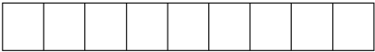

Programme : B. E / B. tech
Course Code : CSA4301
Course Name : Internet programming
Problem Statement (Assignment) Max Marks: 100
Field | Content
Assignment Title | Smart Campus Service Management System
Course Outcome(s) – CO | CO1: Develop visually appealing web pages using CSS for layout and style, and create dynamic, interactive functionality with JavaScript.  CO2: Build dynamic web applications using XML, XSLT, and JSP within the MVC paradigm for efficient data handling and presentation.
Bloom’s Taxonomy Level | L3 – Apply | L4 – Analyze | L5 – Evaluate | L6 – Create
SDG Mapping (SDG 1–17) | SDG 9 - Industry, Innovation and Infrastructure, SDG 4 -  Quality Education
Problem Statement
A university currently relies on manual communication such as emails, phone calls, and paper-based records for reporting and resolving campus service issues. This approach makes it difficult to efficiently record complaints, assign requests to the appropriate service personnel, monitor progress, and provide timely status updates to students and faculty.

The university therefore proposes to develop a Smart Campus Service Management System as an integrated web-based application. The system shall enable students and faculty to submit service requests related to laboratory equipment faults, network problems, classroom maintenance, library services, and other technical issues through a web browser. Users should be able to provide relevant details, submit requests, and subsequently track the status of their requests.
The proposed system should demonstrate an integrated client-server web architecture. The client side shall provide an interactive and user-friendly interface using HTML/XHTML, CSS, JavaScript, and DOM. The server side shall process requests using Java Servlets and JSP, following the MVC architecture. XML shall be used for structured data representation, and XSLT shall be used to transform XML data for presentation where appropriate.

Problem Identification (10 Marks)-The university relies on manual communication (emails, phone calls, paper records) for reporting and resolving service issues, which causes inefficiency in recording complaints, assigning requests, monitoring progress, and providing timely updates.
Proposed Solution -Develop a Smart Campus Service Management System (10 Marks), a web-based application that allows students and faculty to submit service requests (lab equipment faults, network problems, classroom maintenance, library services) and track their status online.
System Design & Architecture - Data Representation (20 Marks) -Implement an integrated client-server web architecture. The client side should use HTML/XHTML, CSS, JavaScript, and DOM for interactivity, while the server side should use Java Servlets and JSP following the MVC model. Use XML for structured data representation for transforming XML data into user-friendly formats for presentation and reporting.
Implementation & Testing (10 Marks) -Demonstrate request submission, assignment to service personnel, progress tracking, and timely updates. Validate inputs, handle errors, and ensure smooth user experience.

STG Goals –SDG 9 - Industry, Innovation and Infrastructure, SDG 4 - Quality Education

Requirement Analysis (SDG 9 – Industry, Innovation & Infrastructure) Identify inefficiencies in manual reporting and propose a digital infrastructure for service management.
Client Interface Development (SDG 4 – Quality Education) Build user-friendly web forms and dashboards so students/faculty can easily submit and track requests, improving access to campus services.
Assessment Criterion | CO Mapping | Weightage / Marks
Problem understanding & formulation | CO1 | 10
Application of course/domain knowledge | CO2 | 20
Solution methodology / design / implementation | CO3 | 20
Use of appropriate modern tools / techniques | CO4 | 10
Results, testing & validation | CO4 / CO5 | 15
Analysis, trade-offs & justification | CO5 | 15
Broader considerations / professional responsibility, where applicable | CO5 | 5
Technical documentation & reflection | CO1–CO5 | 5
TOTAL |  | 100

Performance Level | CO Attainment Percentage | Interpretation
Level 3 | ≥ 70% | CO Attained
Level 2 | 60–69% | CO Moderately Attained
Level 1 | 50–59% | CO Minimally Attained
Level 0 | < 50% | CO Not Attained

Code of Conduct
I __________CH.Bhavya Sri/192411249____________________ (Name / Reg. No.) certify that this submission is my original work and that I have adhered to the guidelines specified for this assessment. I understand that any violation of academic-integrity rules will result in disciplinary action.

Signature of the Student: __CH.Bhavya Sri_____________________
_____________________  Faculty In-charge  Name:  Date: | _____________________  Course Coordinator  Name:  Date: | _____________________  Head of Department  Name:  Date:

1. Problem Identification – 10 Marks
The university currently uses emails, phone calls and paper records to report campus service problems. This manual approach creates several difficulties:
Complaints are difficult to record and organize.
Requests may not reach the correct service personnel.
Students and faculty cannot easily track complaint status.
Progress updates are delayed.
Paper records can be lost or duplicated.
There is no centralized system for monitoring service requests.
Therefore, a digital service-management system is required.

2. Proposed Solution – 10 Marks
The proposed Smart Campus Service Management System is a web-based application that provides a centralized platform for students and faculty.
The system allows users to:
Login to the system.
Submit a service request.
Select the service category.
Enter location and problem description.
Receive a unique request ID.
Track request status.
View assigned service personnel.
Receive progress/resolution updates.
Service personnel can view requests, accept/assign them, update their progress and mark them as resolved.

3. System Architecture – 20 Marks
STUDENT / FACULTY
|
v
+-------------------------+
| Web Browser / Client |
| HTML/XHTML + CSS |
| JavaScript + DOM |
+-----------+-------------+
|
| HTTP Request
v
+-------------------------+
| JSP / Servlet |
| Controller |
+-----------+-------------+
|
v
+-------------+
| Java Model |
| Business |
| Logic |
+------+------+
|
v
+-------------+
| XML Data |
| Repository |
+-------------+
|
v
XSLT Transformation
|
v
User-friendly View

Technologies Used
Component | Technology
Client | HTML/XHTML
Styling | CSS
Interactivity | JavaScript
DOM manipulation | JavaScript DOM
Server | Java Servlet
Presentation | JSP
Architecture | MVC
Data representation | XML
Transformation | XSLT
Communication | HTTP

4. MVC Architecture
Model
Stores service-request information.
Handles request data and business logic.
XML can be used for structured request data.
View
JSP pages display forms, dashboards and request status.
CSS provides user-friendly presentation.
Controller
Java Servlets receive requests from users.
Validate input.
Process the request.
Assign requests to appropriate personnel.
Forward results to JSP pages.

5. XML Data Example
<?xml version="1.0"?>
<serviceRequests>
<request>
<id>REQ001</id>
<name>Bhavya</name>
<category>Network Problem</category>
<location>Block A - Lab 2</location>
<description>Internet is not working</description>
<assignedTo>IT Support</assignedTo>
<status>In Progress</status>
</request>
</serviceRequests>

6. XSLT Purpose
XSLT transforms the XML service-request data into an HTML format that can be displayed in the browser.
<xsl:template match="/">
<html>
<body>
<h2>Service Request Status</h2>
<table border="1">
<tr>
<th>ID</th>
<th>Category</th>
<th>Assigned To</th>
<th>Status</th>
</tr>

<xsl:for-each select="serviceRequests/request">
<tr>
<td><xsl:value-of select="id"/></td>
<td><xsl:value-of select="category"/></td>
<td><xsl:value-of select="assignedTo"/></td>
<td><xsl:value-of select="status"/></td>
</tr>
</xsl:for-each>

</table>
</body>
</html>
</xsl:template>

7. Web Page Output
Your practical/demo can show a page like this:
┌──────────────────────────────────────────────────────────────┐
│ SMART CAMPUS SERVICE MANAGEMENT │
│ University Service Portal │
├──────────────────────────────────────────────────────────────┤
│ Dashboard New Request Track Request │
├──────────────────────────────────────────────────────────────┤
│ DASHBOARD │
│ │
│ ┌────────────┐ ┌────────────┐ ┌────────────┐ ┌──────────┐ │
│ │ 3 │ │ 1 │ │ 1 │ │ 1 │ │
│ │ Total │ │ Pending │ │In Progress │ │ Resolved │ │
│ └────────────┘ └────────────┘ └────────────┘ └──────────┘ │
│ │
├──────────────────────────┬───────────────────────────────────┤
│ SUBMIT SERVICE REQUEST │ REQUEST STATUS │
│ │ │
│ Name: [___________] │ ID Category Status │
│ │ │
│ Category: [Select ▼ ] │ REQ001 Network Resolved │
│ │ │
│ Location: [___________] │ REQ002 Lab Equipment In Progress │
│ │ │
│ Description: │ REQ003 Maintenance Pending │
│ [____________________] │ │
│ [____________________] │ │
│ │ │
│ [SUBMIT REQUEST] │ │
└──────────────────────────┴───────────────────────────────────┘

8. Example Request Submission
User enters:
Name : Bhavya
Category : Network Problem
Location : Block A - Lab 2
Description : Internet is not working
After clicking Submit Request:
✓ Request submitted successfully!

Your Request ID: REQ004
Status: Pending
The request then appears in the dashboard:
REQ004 | Network Problem | IT Support | Pending
After the technician accepts it:
REQ004 | Network Problem | IT Support | In Progress
After solving the issue:
REQ004 | Network Problem | IT Support | Resolved

Implementation & Testing – 10 Marks

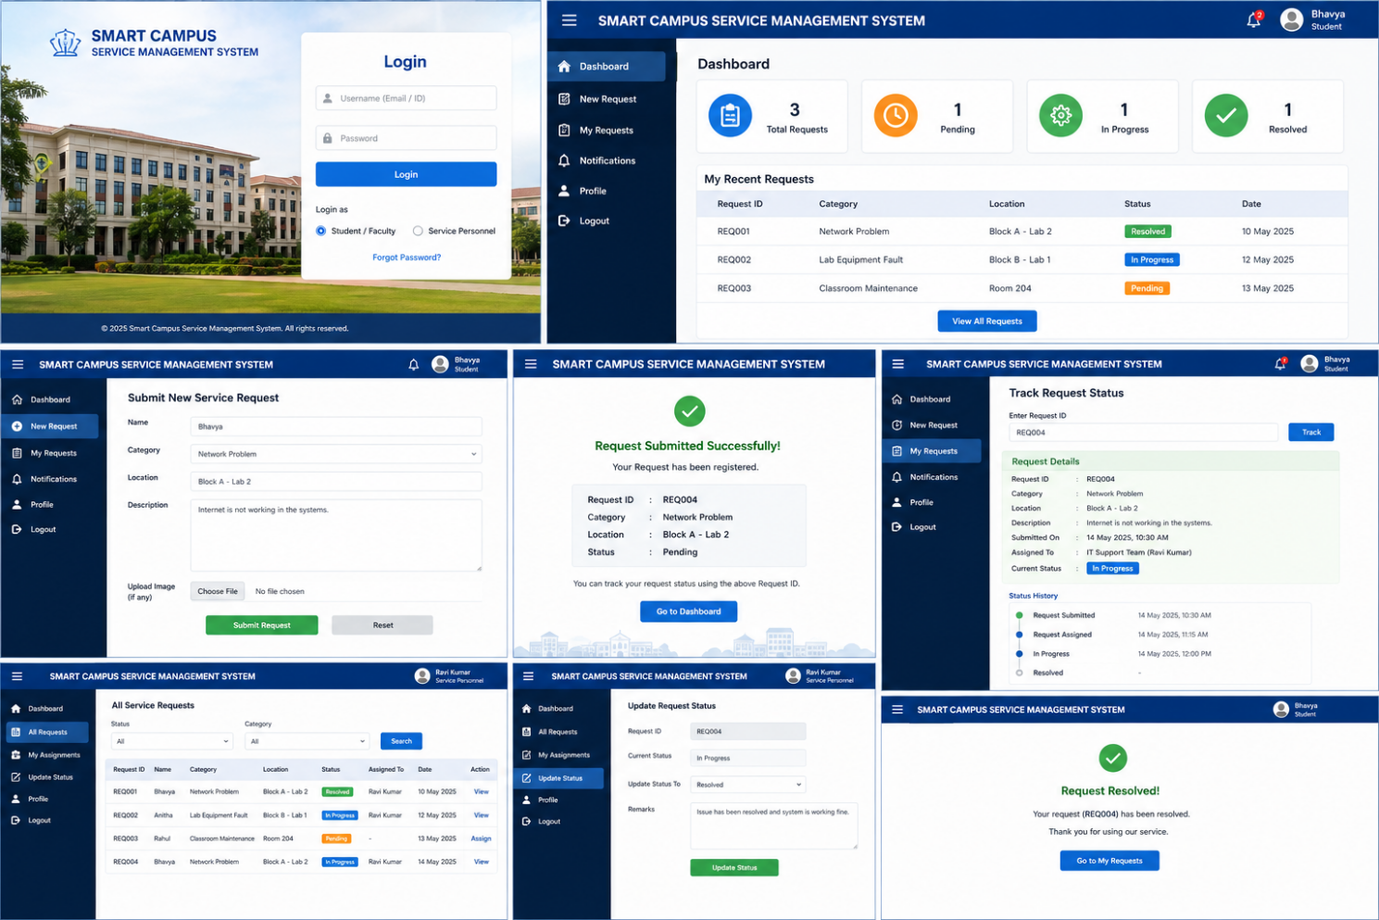
The following test cases can be demonstrated:
Test Case | Expected Result
Submit valid request | Request successfully created
Empty name | Validation error displayed
Empty description | Validation error displayed
Select service category | Category stored correctly
Assign technician | Request assigned successfully
Update status | Status changes correctly
Track request ID | Correct request details displayed
Resolve request | Status changes to Resolved

